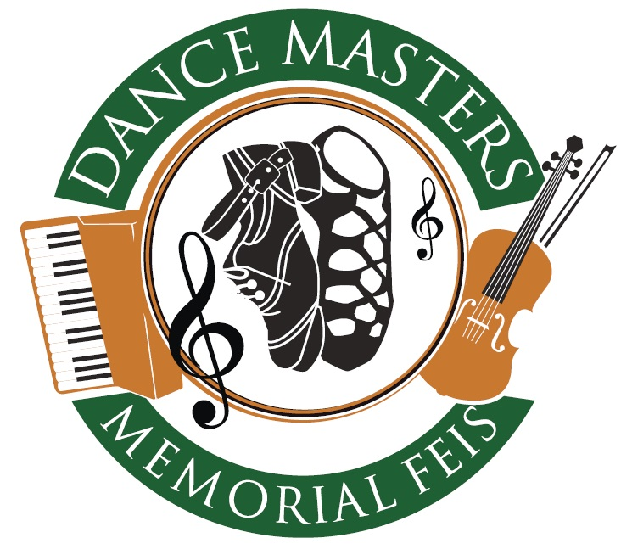

Mount Errigal Hotel, Letterkenny Co.Donegal
20th & 21st October 2018

Presented By
Derry & Donegal Teachers’ Association
Moltóirí: Fiona McCabe, Dublin
Maggie Lynch, London
Derek Fahy, Tuam
Michelle McKernon, Belfast

Ceoltóirí: Seamus O'Sullivan, Glasgow
Liam O'Sullivan, Newcastle
