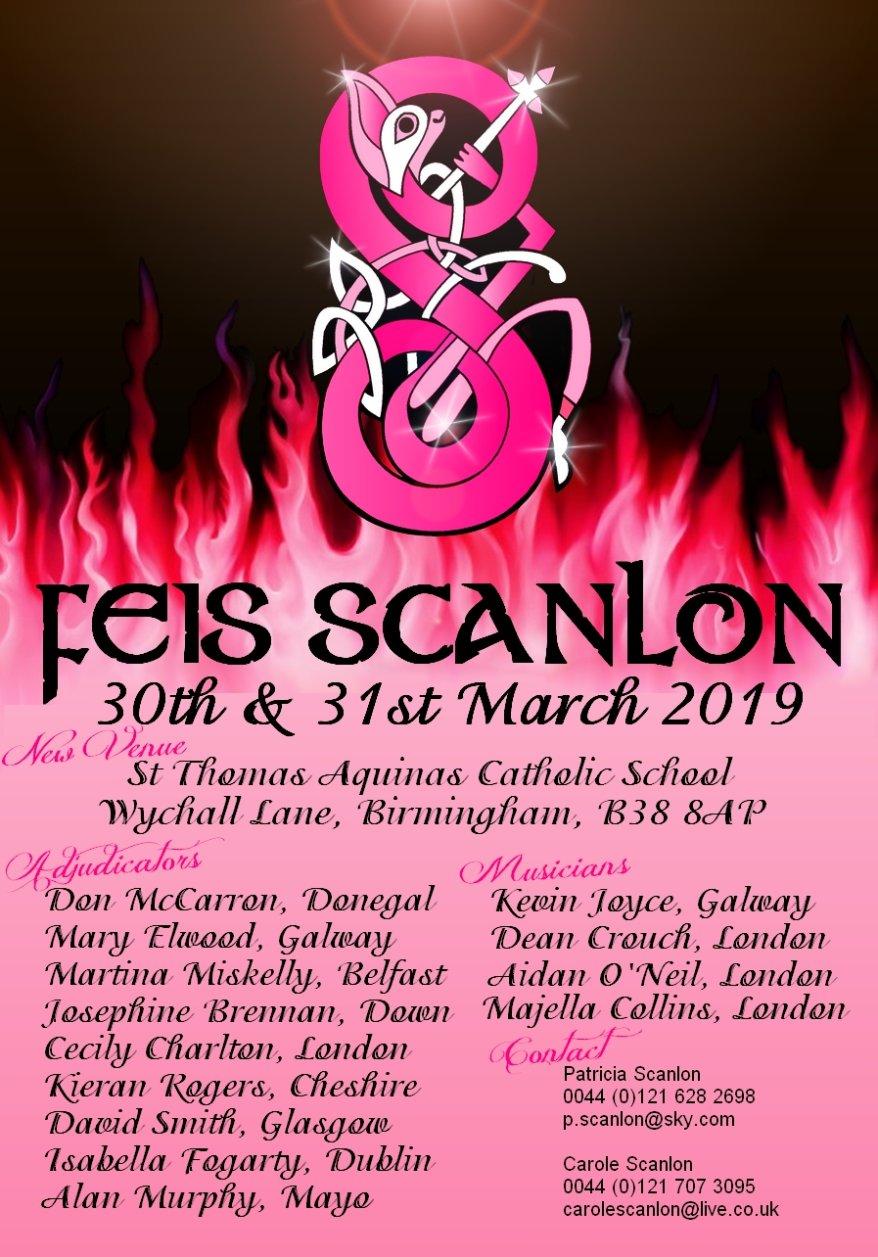

In Loving Memory of John Scanlon

##### June 1922 – March 2007

The Scanlon Feis is held in loving memory of our father, John Scanlon, who passed away in March 2007. He was a great advocate of our Irish Dancing and supporter of all activities for young people – especially those which promoted our Irish culture. It is an honour for us to hold our Feis in his memory.

It is once again our pleasure to invite you to the Scanlon Feis 2018. We are pleased to be holding our feis at a brand new venue- **St Thomas Aquinas Catholic School, Wychall Ln, Birmingham B38 8AP**

**NEW FOR 2019 – Separate Boys Competitions (double age groups)**

This year we are running separate boys competitions in the following age groups – U10 – U11, U12 – 13, U14 – 1U15, U16 – U17 and Over 17s

St Thomas’s has excellent facilities for both spectators and competitors. There is a large stage in the main hall, a purpose built stage in the gym and also 4 staged floors in the large sports hall. It is within easy access of the motorway links and also only 25 mins from Birmingham International Airport.

*Facilities also including ample parking and the grounds are secure and safe for the children.*

***Also new for 2019 -* Scanlon Feis is delighted to launch for 2019 our TINY TOTS section.**

This is aimed at all the little ones who love irish dancing but aren’t quite ready for an open competition.We want to make this a fun and memorable experience for our newest irish dancers so each child will perform 16 bars of easy reel music , they will be introduced to our adjudicator and also will be counted in to know when to start to the music.

The entry fee is £5.00 per child and each dancer will be awarded with a prize to mark their participation in their first Scanlon Feis. We will also automatically award ALL of our registered TINY TOTS competitors at SCANLON FEIS with 1 point towards the coveted Schools Points CUP!

***Please note that we will be using the 32 bar system in grade solo dances (Novice, Primary, Intermediate – for ALL age groups plus Open solo dances in U6 7 8 and 9s) as per the last 2 years.***

*ALL dancers in the competition will be lined up at the back of the stage at the start of the competition. The adjudicator will take down the numbers of all competitors. The first two dancers walk to the starting positions and get ready to dance. After the 8 bar introduction the dancers will begin their dance and dance for 32 bars*. After 32 bars* they bow (quickly) and return to their original place in the line at the back of the stage whilst the next two dancers step commence their performance of 32 bars.*

*The trad set dance competition will not be restricted to 32 bars. Dancers will complete the full traditional set dance (step on right and left foot, set only on the right foot).*

Over the duration of the feis points will be awarded for all 1st 2nd and 3rd places in all grades, in all dances. The school with the most points at the end of the feis is awarded with the John Scanlon Memorial Trophy.

We have nine fine adjudicators and four excellent musicians. Entries are on the day. Computer print-out for all championship results will be available. We will have our usual high standard of catering facilities providing hot and cold drinks and snacks during the day.

We have ICONIC Dancer ([www.theirishdancer.co.uk](http://www.theirishdancer.co.uk)) – selling shoes, socks, sock glue, tiaras etc. Follow SCANLON FEIS via Facebook to keep up-to-date with results and pictures over the weekend.

We look forward to seeing you all at the Feis and thank you again you for your continued support

**Entry Fees: Pay on the day**

All solo dances …£3.00 All Trophy competition…£4.50 Tiny Tots Special Competition…5

Under 6, 7 Solo Championship .£24.00

*includes 2 x tickets for compulsory solos plus set of Marks on submission of no to office*

Under 8, 9 Solo Championship £27.00

*includes 2 x tickets for compulsory solos plus set of Marks on submission of no to office*

***NB 2 SOLO ROUNDS MUST BE COMPLETED BEFORE ENTERING U6 7 8 9 CHAMPS***

***Solo tickets can also be purchased if more than 2 solos wished to be danced.***

Open & Preliminary Championships Under 10 upwards £30.00

*Includes solo results in first 2 rounds of championship and a set of Marks on submission of no to office)*

Ceili/Figure Championships £20/£40 per team Family Fee £70.00

Party Night – Saturday 30th March - (children welcome) at

Scanlon’s Bar, Spring Road B11 3DW

After a long day at the feis you are all welcome to join us to party or just to relax and unwind

**RULES**

These rules should be read in conjunction with rules laid out by An Coimisiun Le Rinci Galeacha.

1. **GENERAL**
   1. Adjudicator’s decision is final.
   2. Committee members only may approach adjudicators.
   3. Any protest against breach of rules must be made in writing to the feis organiser within one hour of conclusion of a competition, with a fee of £10.00. Should the objection be upheld the fee will be refunded.
   4. Entries will only be accepted from schools registered with An Coimisiun.
   5. Lodgement of entries at a feis implies that you accept the rules relating to the feis in their entirety as laid down by the An Coimisiún le Rinci Gaelacha & Midland Regional Council.
2. **AGE GROUPS**
   1. Age to be taken from 1st January of the current year. Where a competitor's birthday falls on 1st January he/she shall, be regarded as under the age attained on that day.
   2. Competitors must dance in their own age group for solo competitions except where there is no provision for that dance in that age group.
3. **GRADES**
   1. **Novice** – Confined to competitors who have not progressed out of Novice grade (including Trophy Competitions) for that particular dance in any age group

**Primary** - Confined to competitors who have not progressed out of Primary grade (including Trophy Competitions) for that particular dance in any age group.

**Intermediate** – confined to competitors who have not progressed out of Intermediate grade (including Trophy Competitions) for that particular dance in their present age group.

**Open** – Open to all dancers.

* 1. All grade competitions are open to all regions.
  2. No competitor may compete in the same competition more than once
  3. In a trophy competition, a dancer must have performed their choice of dance in the solo competition.
  4. Grade Progression is as follows:

|  |  |  |
| --- | --- | --- |
| Grade | No of Entries | No of dancers to progress |
| Novice & Primary | 5 or less | 0 |
| 6-10 | 1 dancer |
| 11 – 20 | 2 dancers |
| 21+ | 3 dancers |
| Intermediate | 5 or less | 0 |
| More than 5 | 1st place only |

1. **PRELIMINARY/OPEN CHAMPIONSHIPS AND PREMIER COMPETITIONS:**
   1. Championship/Premier Competitions - Only Intermediate and Open dancers are eligible to compete (except under 6 and 7 – see below).
   2. Competitors can only dance in either Preliminary or Open Championship; they may not compete in both.
   3. PRELIMINARY CHAMPIONSHIP -To compete in a Preliminary Championship a competitor cannot have been placed 1st, 2nd or 3rd in an Open championship or 1st in a Preliminary Championship in this current year, providing there were 10 or more competitors. NB – 10 dancers must have danced the required dances for the championship. The Midlands region allow dancers to participate in 1 round of preliminary champs as a separate solo round
   4. Under 6s & under 7s Championships/Premier must dance Reel & Light Jig. A recall is at the discretion of the feis organisers. All grades are allowed to compete but **must have performed these dances on the day of the feis**.
   5. Under 8s and Under 9s must dance Reel and Heavy Jig. A recall is at the discretion of the feis organisers. To be eligible to compete, dancers must perform 2 dances in the solo rounds on the day of the feis.
   6. Under 10 and up. All dancers should be given a choice of Reel or Slip Jig and Jig or Hornpipe and recall set dance.
   7. Subsidiary solos may be run at the discretion of the feis organisers.
   8. IF a minimum number is stated for ANY championship to be held, then this must be consistent for ALL championship competitions.   E.g. if you decide on a minimum number of 5 in order to run a separate boys or prelim championship then this must be consistent with the number required to run any championship.  This may well be prevalent in the younger age groups where numbers can be low.  For example if you have this rule on your syllabus and you only have 4 entries for Under 6 – you should not run the championship.
2. **DANCE MOVEMENTS**
   1. Rules appertaining to Dance movements such as toe movements, metronomic speeds as laid out by An Coimisiun apply.
   2. In Novice Grades only basic steps should be performed i.e. no intricate movements, clicks, rocks, twists, etc.
3. **COSTUME & MAKE-UP**
   1. All costume and make-up rules as set out in CLRG rules must be adhered to EXCEPT see * in 6.2:
   2. All competitors in all age groups in Novice may only wear traditional class costumes or long / short-sleeved blouses / polo tops and skirts / tunics that conform to the regular costume length rules as above. Low-cut tops and short, tight skirts are not permitted. * **NB Primary competitors in the Midlands Regional are allowed to wear solo costumes**.
   3. Adjudicators who determine a costume to be too short or to lack modesty may use the Costume Infraction (Tick Box) Program in order to flag the dancer and ensure the teacher is notified. As the Costume Infraction Program is used for ALL costume violations, adjudicators wishing to specify length as the infraction can write the letter ‘L’ in the Tick Box column.
   4. Under no circumstances should dancers walk around any dancing venue in their underwear. Neither should dancers (regardless of age) change into or out of costume in the main dancing hall, if at all possible. At all times, dancers should be properly attired.
   5. Make-up, including false eyelashes and tan on face, is not be permitted for any dancer in solo or team competition up to and including the under 10 age group. Nor in the first two grades up to and including the under 12 age group. Leg tan is NOT part of this rule.
4. **FIGURE AND CEILI**
   1. In Figure and Ceili competitions - rules regarding age and re-dancing as laid out by An Coimisiun apply.
   2. Figure Championship in the U7’s year group may be a 6 hand dance, 8 hand Ceili or Figure Dance of 6 or more
   3. Ceili 8 Hand competitions any 8 Hand may be performed in accordance with Ar Rince Foirne.
   4. Mixed Ceili – A mixed team must consist of at least 2 boys or 2 girls.
5. **MEDIA POLICY**

Any form of unauthorised photography which has the capability to capture a dancer’s image whilst in motion, using electronic or manual means e.g. mobile phone, standard camera, video camcorder, commercial film, with or without enhancement, is expressly forbidden during competitions.

1. **CARRIAGE AIDS** 
   1. Any competitor found to be using artificial carriage aids and subsequently refuses to remove same, will be subject to disqualification from that particular competition. Medically prescribed apparatus (proof of which may be required) will be exempt from this ruling.
   2. Any competitor wearing their shoes on the wrong feet will be treated in the same manner as if using carriage aids and be subject to disqualification from that particular competition.
   3. In order to comply with health and safety measures, all dancers lining up side stage prior to any round of a competition will be required to perform the simple exercise of raising arms to shoulder level unhindered. If unable to do this due to costume stitching or arm attachments, by the time of their rotation, these dancers will not be permitted to perform.
2. **ORDER OF DANCING, CONDUCT, MISHAPS ETC**
   1. Should a dancer lose a heel or a complete shoe or have an open lace he/she may stand back – allowing the other dancer(s), where applicable, to continue dancing uninhibited. In such a case the dancer concerned will be permitted to redance as soon as it is deemed practicable by the stage steward.
   2. Should a dancer fall on stage, whether in solos or in teams, the adjudicator MUST ring the bell to stop the performance of the dancer(s). Dancers so affected will be permitted to redance and will be marked then at the discretion of each individual adjudicator. If a dancer falls during the last 8 bars of any performance, then he/she would only be required to dance the last 16 bars of that dance.
   3. Should a dancer slip, bump into another dancer or have a costume malfunction whether in solos or in teams, the bell will be rung at the discretion of the adjudicators to stop the performance of the dancer(s). Dancers so affected will be permitted to redance and will be marked then at the discretion of each individual adjudicator.
   4. Where a dancer fails to complete his / her performance in any given round, that dancer will automatically receive ZERO marks from all adjudicators for that round.
   5. Competitors beginning to dance before or after the stipulated set dance introduction will automatically receive ZERO marks from all adjudicators for that round.
   6. A competitor must not walk off the stage during a performance unless instructed to do so by an adjudicator. A dancer who dismisses themselves from the stage without the permission of an adjudicator will not be marked for that particular dance.

|  |  |  |  |  |  |  |  |
| --- | --- | --- | --- | --- | --- | --- | --- |
| **PROGRAMME OF DANCES** | | | | | | | |
| **\* * * * New for 2019 – 2 yearly boys championships * * * \*** | | | | | | | |
| **Age Grp** | **Novice** | **Primary** | | **Intermediate** | | **Open** | |
| Tiny Tots | Ungraded Special competition | | | | | | |
| Under 6 | Reel | Reel | | Reel | | Reel | |
| Under 7 | Hop Jig | Hop Jig | | Hop Jig | | Hop Jig | |
|  | Light Jig | Light Jig | | Light Jig | | Light Jig | |
|  | Slip Jig | Slip Jig | | Slip Jig | | Slip Jig | |
|  | Trophy Light Dance | Trophy Light Dance | | Trophy Light Dance | |  | |
| Ungraded | Heavy Jig, Hornpipe, Trad Set Dance, Trophy Heavy Dance* | | | | | | |
| Under 8 | Reel | Reel | | Reel | | Reel | |
| Under 9 | Hop Jig | Hop Jig | | Hop Jig | | Hop Jig | |
|  | Light Jig | Light Jig | | Light Jig | | Light Jig | |
|  | Slip Jig | Slip Jig | | Slip Jig | | Slip Jig | |
|  | Trophy Light Dance | Trophy Light Dance | | Trophy Light Dance | |  | |
|  | Heavy Jig | Heavy Jig | | Heavy Jig | | Heavy Jig | |
|  | Hornpipe | Hornpipe | | Hornpipe | | Hornpipe | |
|  | Trad Set Dance | Trad Set Dance | | Trad Set Dance | | Trad Set Dance | |
|  | Trophy Heavy Dance | Trophy Heavy Dance | | Trophy Heavy Dance | |  | |
| Under 10 | Reel | Reel | | Reel | | **PLEASE NOTE – NEW!!!** | |
| Under 11 | Hop Jig | Hop Jig | | Hop Jig | | Dancers, who are ineligible to dance in the intermediate grade for Reel, Slip Jig, Heavy Jig or Hornpipe may enter for just 1 round of the championship ie light OR heavy (£3). This is particularly pertinent for younger/new dancers who may have gained a 1st place in the intermediate grade but are not quite ready for full preliminary championships level. Separate solo results are awarded in each round of the championship. | |
| Under 12 | Light Jig | Light Jig | | Light Jig | |
|  | Slip Jig | Slip Jig | | Slip Jig | |
|  | Trophy Light Dance | Trophy Light Dance | | Trophy Light Dance | |
|  | Heavy Jig e | Heavy Jig | | Heavy Jig | |
|  | Hornpipe | Hornpipe | | Hornpipe | |
|  | Trad set Dance | Trad Set Dance | | Trad Set Dance | |
|  | Trophy Heavy Dance | Trophy Heavy Dance | | Trophy Heavy Dance | |
| Over 12 |  | Reel | |  | |
|  |  | Hop Jig | |  | |
|  |  | Light Jig | |  | |
|  |  | Slip Jig | |  | |
|  |  | Trophy Light Dance | |  | |
|  |  | Heavy Jig | |  | |
|  |  | Hornpipe | |  | |
| Trad Set Dance | |
|  |  | Trophy Heavy Dance | |  | |
| Under 14 |  |  | | Reel | |
| Over 14 |  |  | | Hop Jig | |
|  |  |  | | Light Jig | |
| (Maybe combined if insufficient entries) |  |  | | Slip Jig | |
|  |  | | Trophy Light Dance | |
|  |  | | Heavy Jig | |
|  |  | | Hornpipe | |
| Trad Set Dance | |
|  |  |  | | Trophy Heavy Dance | |
| **PRELIMINARY CHAMPIONSHIPS** : Under 10, 11, 12, 13, 14, 15, Over 15 | | | | | | | |
| **OPEN GIRLS CHAMPIONSHIPS**: Under 10, 11, 12, 13, 14, 15, 16, 17, 19 and Senior | | | | | | | |
| **OPEN BOYS CHAMPIONSHIPS**: Under 11, 13, 15, 17 and Over 17 | | | | | | | |
| **Ceili & Figure Competitions:** Under 9, 11, 13, 16, Under 19 (Ceili only) & Senior | | | | | | | |
| **Open and Preliminary Championships – required dances** | | | | | | | | | |
|  | | | | **1st Dance** | | **2nd Dance** | | **Recall** | |
| Under 6 & 7 Open Championship | | | | Reel | | Light Jig | |  | |
| Under 8 & 9 Open Championship | | | | Reel | | Heavy Jig | | Trad Set | |
| Under 10–Senior Open & Preliminary Champs | | | | Jig or Hornpipe | | Reel or Slipjig | | Open Set Dance | |

