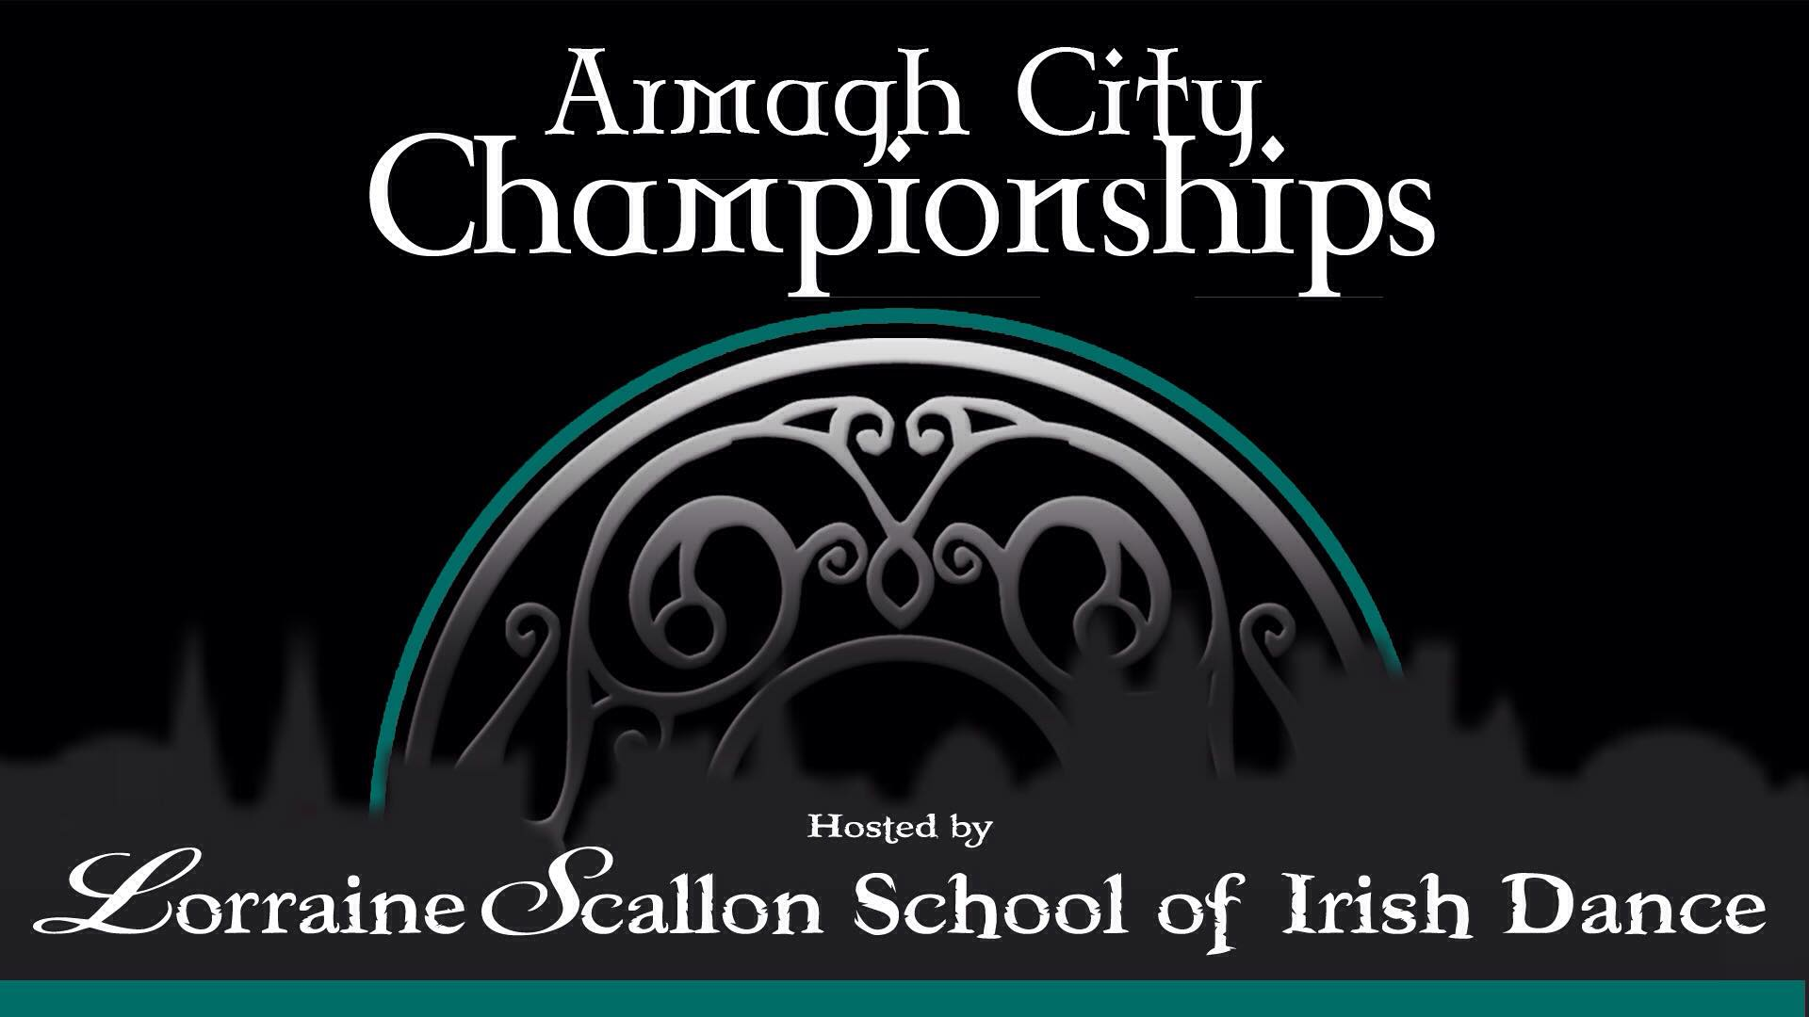

Armagh City Hotel
2 Friary Road, Armagh BT60 4FR
Saturday 1st – Sunday 2nd June 2019
Adjudicators:

Terry McKevitt – Dundalk
Mark McCole – Galway
Cheryl Nolan – Mayo
Alan Scariff – Galway
Caroline Duggan – Mayo
Virginia Travis – Manchester

Musicians:
Stephen Carolan – Drogheda
Paul O'Donnell – Antrim

Charity Treble Reel step down the line (16 Bars) – Adjudicator will judge with their back to the stage*

*Prize money for the Champion of champions*

This year’s chosen charity will be the Northern Ireland Children’s Hospice

All Enquiries to:
Carol Robinson 075 2115 8861/078 3335 7813 (Teachers only please)
armaghcitychampionships@yahoo.com

Syllabus approved by feis registrar, An Comhairle Uladh Kevin Armstrong
Dear Teachers, Parents and Dancers,

The Lorraine Scallon School of Irish Dancing warmly invites you to the Armagh City Championships on Saturday 1st – Sunday 2nd June 2019 in The Armagh City Hotel.

There will be two Stages and a large practice area.

A special feis rate has been agreed with the host Hotel. Please contact the Armagh City Hotel directly on 028 37 518888 to avail of these rates.
- Single £89
- Double £109
- Treble £135
Prices include breakfast and use of leisure facilities.,
Armagh City hotel have a strict policy that only food purchased in the hotel can be consumed

We have had to put a strict email entry deadline as Friday 24th May 2019 in order to keep our Championship day running smoothly. We urge all teachers to have their Championship entries emailed to armaghcitychampionships@yahoo.com before this date and the dancers can pay on the day.
We look forward to welcoming you all to a weekend of excellent dancing.

Lorraine Scallon TCRG ADCRG

Entry Fees
- Open Championships U6 – Senior £25
(2 solos results)
- Open & Preliminary Championship Combined £30
(Dancers can be placed in both)
- Teams £2 (per person)
- Solo Competitions £4 (per dance)
- Trophy dances £5
- Charity Blind Treble Reel £5

Closing date for entries: 24th May 2019
Entries: One cheque per school please (sterling cheques only)
Admission: £5 sterling
Payments details on entry sheet: Page 7
Directions: Page 8

Dances
U6 & U7 Championship – Reel, Single jig, Light or heavy jig
U8 & U9 Championship – Reel, Jig, Traditional Set Dance
U10 – O18 Championship – Reel or Slip Jig, Heavy Jig or Hornpipe, Set dance on recall

FEATURE

This year’s feature is a Charity Treble Reel step down the line
Dancers will perform 16 bars of a treble reel in step down the line and will be judged by one adjudicator who will have their back to the stage.

1st place will be presented with a Perpetual cup.

Proceeds will go to the Northern Irelands Children’s Hospice

Prize money for the Champion of Champions

In Championships:
A panel of three adjudicators will judge the first two rounds.
A panel of three different adjudicators will adjudicate the set dance round.
In an age group with 15 competitors or less will be 100% recall.
Preliminary Championships from U8 – U16 (Results will be based on the first 2 rounds)

Trophies and sashes will be awarded to 1st - 5th in Championships
Trophies and sashes will be awarded to 1st – 5th In Preliminary Championships
Trophies will be awarded 1st – 5th and 1st place sash in all trophy dances

Rules:

- Adjudicator’s decision is final.
- Age as at 1st January 2019.
- Entries only accepted from teachers currently registered with An Coimisiúin le Rincí Gaelacha.
- In Bungrad and Tusgrad, makeup will not be permitted in competitions up to and including U12 age group. Dancers in all ages must wear either class costumes or 'day clothes'.
- Bungrad competitions are confined to dancers who have never won 1st place for that particular dance in any age or grade. Basic steps only are permitted.
- Tusgrad competitions are confined to dancers who have never won 1st place in that particular dance in any age in Tusgrad, Meangrad or Ardgrad. Dancers may perform basic steps or first hard version of each dance. Steps in Tusgrad Heavy Jig or Hornpipe must be similar to those used in St. Patrick’s Day or Blackbird.
- Meangrad competitions are confined to dancers who have never won 1st place in that particular dance in Meangrad or Ardgrad in that age group or a higher age group.
- No block, en pointe, stationary or moving, will be allowed for all ages up to and including under 12 years.
- The feis committee reserves the right to use relief adjudicators and/or alternate competitions if it becomes necessary, in order to help the feis run smoothly.
- Any form of unauthorized photography which has the capability to capture a dancer’s image whilst in motion, using electronic or manual means, e.g. mobile phones, standard camera, video camcorder, cine recorder, commercial film, with or without flash enhancement, is expressly forbidden in competition.
- Eligibility for Preliminary Championships
  - Never previously won an Open Championship
  - Never previously won more than 3 Preliminary Championships
  - Not qualified for Oireachtas Rince Na Cruinne 2018/2019
- Dancers recalled for the set dance will be included in results for both Open and Prelim Championship. Dancers to be included in the Prelim Championship must be ticked on the entry form submitted.
- All grades are open to all regions worldwide.
- The feis committee will not be held responsible for any personal injury, loss or damage to property
- All perpetual awards must be signed for. The recipients are responsible for any loss or damage and for the safe return of the perpetual award prior to the following year.
- All competitors are asked to be ready in full costume 30 minutes before competition.
- Make-up (including false eyelashes) is not permitted for dancers in either solo or team competitions up to or including the U10 age group. For the purposes of this rule the term ‘make-up’ includes tinted moisturiser and any artificial tanning products.

Saturday 1st June

Championships

Time | Stage 1 | Dances | Stage 2
8.30am | 9-11 Boys  First 2 rounds  U10 and U11 Girls First 2 rounds | Jig/Hornpipe Reel/Slip Jig | U6 and U7 (3 rounds)  Reel, Single Jig, Jig
10.00am | 11-13 Boys  First 2 rounds  U12 and U13 Girls First 2 rounds | Jig/Hornpipe Reel/Slip Jig | Boys 9-11 Sets  Girls U10 and U11 Sets
12 noon | U8 and U9 Mixed All 3 rounds | Reel, Jig, Traditional Set | Boys 11-13 Sets  Girls U12 and U13 Sets
U13 | Junior Charity Treble Reel | Step down the line 16 Bars
2.30pm | 13-15 Boys  First 2 rounds  U14 and U15 Girls First 2 rounds | Jig/Hornpipe Reel/Slip Jig
4.00pm | 15-17 Boys  First 2 rounds  U16 and U17 Girls First 2 rounds | Jig/ Hornpipe Reel/ Slip Jig | 13-15 Boys Sets  Girls U14 and U15 Sets 15-17 Boys Sets
5.30pm | 17+ Men  First 2 rounds  U18 and O18 Ladies First 2 rounds | Jig/Hornpipe Reel/Slip Jig | U16 and U17 Girls Sets 17+ Men Sets  U18 and O18 Girls Sets
O13 | Senior Charity Treble Reel | Step down the line 16 Bars
 | Parade of Champions Competition | Top 3 dancers in each championship  *Prize money for the Champion of champions*

Results will be given out as they are ready.

Sunday 2nd June

Grades/Ceilis

Time | Stage 1 | Stage 2 | Stage 3
9.00am | U8 Bungrad | U9 Bungrad | U10 Bungrad
10.30am | U8 Tusgrad | U9 Tusgrad | U10 Tusgrad
12 noon | U8 Meangrad | U9 Meangrad | U10 Meangrad
Lunch
2.00pm | U12 Bungrad | U7 Bungrad | U5 Ungraded reel  U6 Bungrad
3.30pm | U12 Tusgrad | U7 Tusgrad | U6 Tusgrad
5.00pm | U12 Meangrad | U7 Meangrad | U6 Meangrad
6.00pm | O12 Bungrad  O12 Tusgrad  O12 Meangrad |  | Ceili U12  Ceili u15  Ceili O15

Dances:
Bungrad – Easy reel, single jig, light jig, slip Jig, light trophy dance
Tusgrad – Reel, single jig, slip jig, light jig, light trophy dance, heavy trophy dance
Meangrad – Reel, single jig, slip jig, light/heavy jig, light trophy dance, heavy trophy dance

Armagh City Championships 2019 Entry Form:

Child’s Name | D.O.B. | School | Fee | Prelim

All Cheques to be made payable to: Lorraine Scallon School of Irish Dance

Please email or post to:
Maura Kelly
15 St. Patrick’s Park
Armagh
BT60 4BQ
armaghcitychampionships@yahoo.com

Directions to the Armagh City Championships 1st & 2nd June 2019 in the Armagh City Hotel
2 Friary Rd, Armagh BT60 4FR Coordinates N 54°20.706’ W 006°38.983’

*All Championships dances will be held on Saturday 1st June 2019*
*All Grades dances will be held on Sunday 2nd June 2019*

Travel times from local airports
Belfast international Airport – 50 mins
Belfast City George Best – 55 mins
Dublin Airport – 75 mins

From Dublin
- Get on M1 heading northbound
- Continue north M1 – N1 – A1 (Continuous road). This road has €1.90 toll
- Take exit for Armagh Craigavon (A28) from A1
- At the roundabout take 1st exit A28 Armagh
- Follow A28 until road ends
- Take left slip road onto Friary Rd/A3
- Armagh City hotel is on the left.

From Belfast
- Get onto M1 Signposted the West, The South, Dublin
- At junction 11, take the M12 exit to Craigavon/Portadown/Armagh
- At the roundabout, take the 1st exit onto M12 heading to Craigavon/Portadown /Armagh
- Turn left onto Northway/A3
- At the roundabout, take the 2nd exit onto Armagh Rd/A3
- At the roundabout, take the 2nd exit onto Portadown Rd/A3
- At the roundabout, take the 1st exit onto Drumadd Rd
- Continue straight through 2 sets of traffic lights
- Armagh City Hotel is on the right

From the West
- From Ballygawley Roundabout
- Take exit signposted Aughnacloy (A5), Dublin (A5). Armagh (A28)
- Continue to follow A5 through Aughnacloy
- Leave Aughnacloy continuing on A28
- Enter Village of Caledon, take right continuing on A28
- Continue onto Friary Rd
- Armagh City Hotel is on the right just after traffic lights
From the North
- From the Stangmore Roundabout Dungannon
- Exit the roundabout onto A29 Signposted Moy, Armagh
- At the roundabout, take the 3rd exit onto Railway St/A29
- At the roundabout, continue straight onto The Mall/Rokeby Green/A3
- At 1st traffic lights Turn right onto Barrack St/A3
- Continue straight through 2nd traffic light
- Armagh City hotel is on the left

From the South West
- From Coolshannagh Roundabout Monaghan
- Take exit signposted Armagh N12
- Continue to follow N12
- Continue though the village of Middletown
- Continue onto Monaghan Rd/A3
- Continue to follow A3
- Turn left onto A29/A3 (Opposite St Malachy Chapel)
- Turn left onto Friary Rd
- Armagh City Hotel is on right after traffic lights

